**Diagrams**

**Class Diagram:**

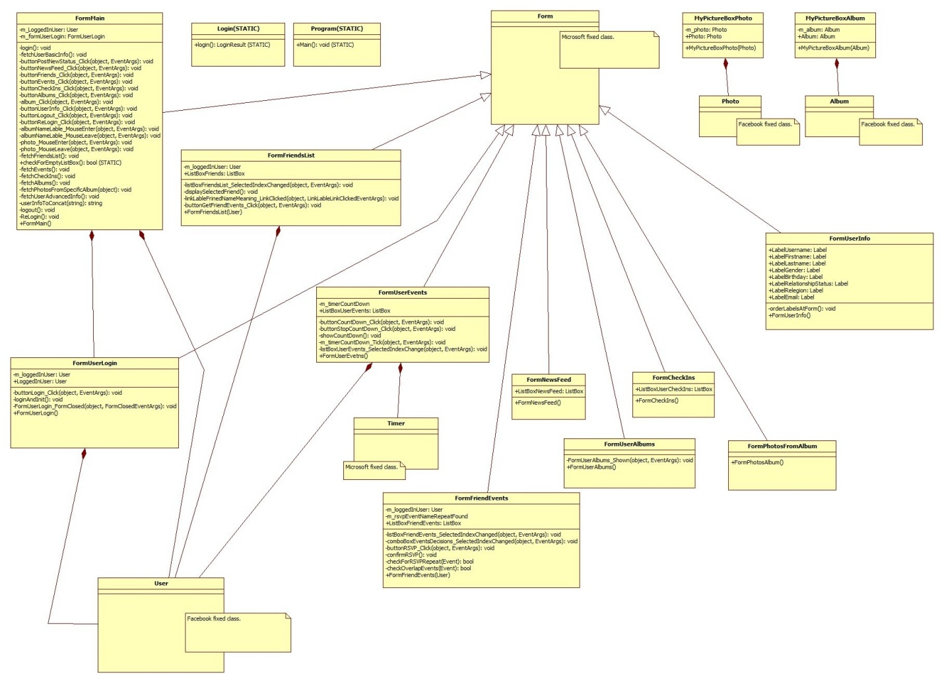חסר שימוש במצייני תפקיד שימוש וכמות -4

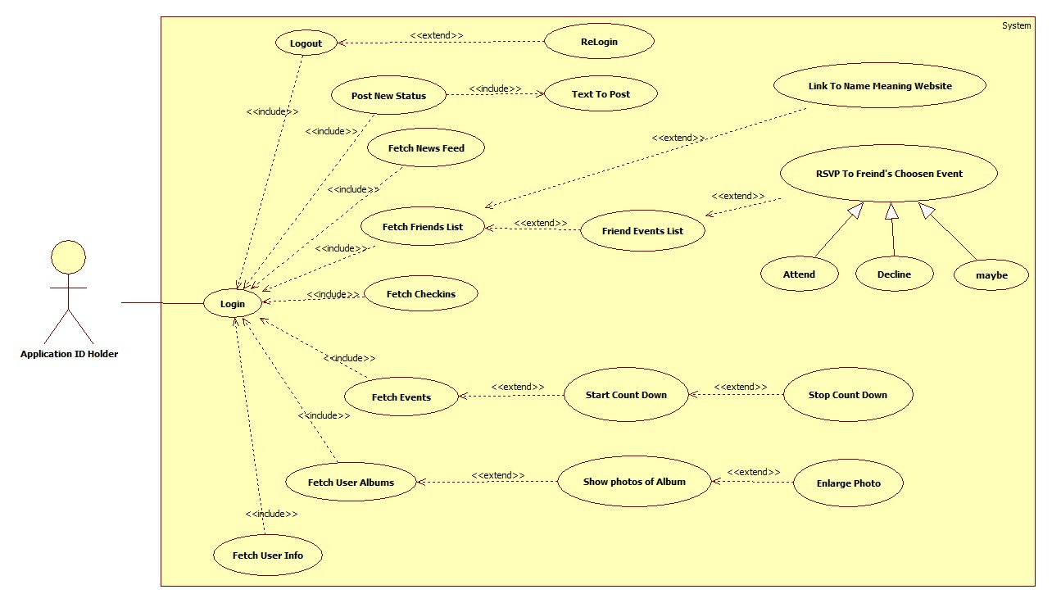**Use Case Diagram:**

**נדרש לתת שם טוב יותר למערכת -1**

**המערכת עושה שימוש בשרתי פייסבוק לכן צריך לציירהה כמערכת חיצונית -1**

**המשתמש עושה שימוש גם בפיצרים לכן היה צריך לצייר קו בינו לבין הפיצרים 0**

**Sequence Diagram:**

1. **Event Count Down**

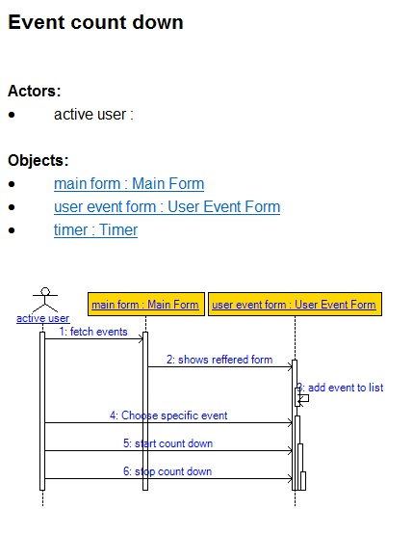

**נדרש לצייר גם הודעות חוזרות (-2)**

**Fetch events פעולה שלוקחת זמן לכן צריך לציירה כקו נטוי**

1. **Event RSVP & Overlapping notifier**

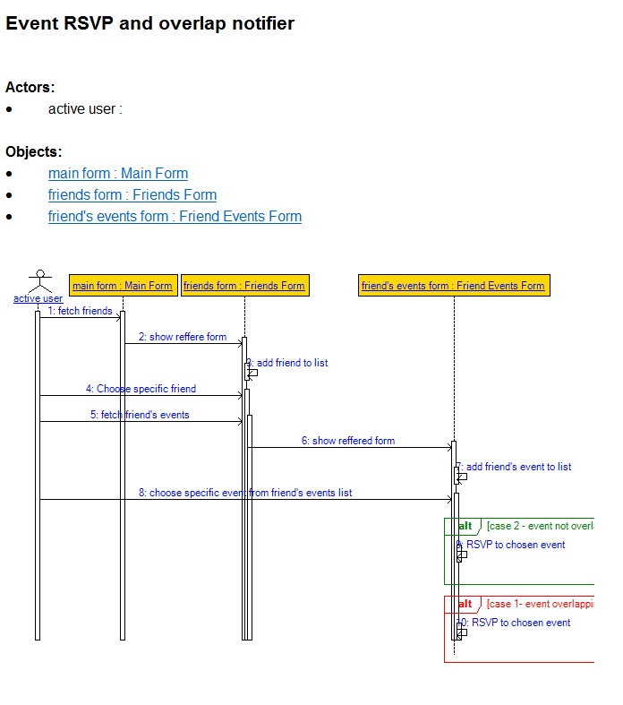

1. **Login**

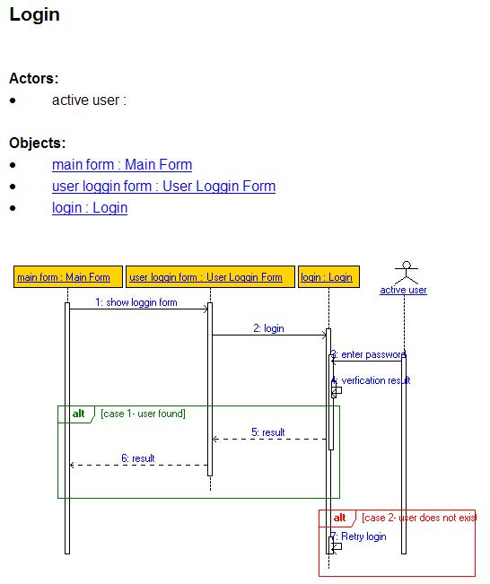

**Features Explanation**

1. **Events count down.**

**(can be found in class FormUserEvents in method showCountDown row number 43)**

User can choose any of the events that were already RSVP (as attending or as maybe), once choosing an event and pressing on the start count down button a timer will be started presenting the remaining time to the beginning of the event (the timer will be updated on intervals of 1 sec).

User can switch at any time the event by another and the timer will immediately show the relevant event count down.

An additional button was added to stop the count down.

Once the event start time has arrived, the timer will set to 0:0:0:0, the text box will change to “event happening now”, a message box will open with the same text and a sound will be played for the user’s attention.

1. **Joining events that your friends have confirmed and being notified for overlapping events taking place at the same time (attending/ maybe. Open events only).**

**(can be found in class formFriendEvents in method “confirmRSVP” row number 59)**

Given the user the possibility to choose a friend from the friend list and fetch the events that friend has RSVP to, then choose the desired event and RSVP to it. If user is trying to confirm (attend/ maybe) an event that takes place at the same time as a former event a message will be shown saying that there is already an event happening to warn/ remind the user of those overlapping events.

1. **Google direct access through the facebook application.**

**(can be found in class FormMain in method “pictureBoxGoogle_click” row number 405)**

User needs to enter his desired value to search and by clicking the Google Icon it will automatically open an explorer web page with the relevant results from the google’s search engine.

1. **Providing friend’s first name meaning.**

**(can ve found in class FormFriends in method “linkLabelFriendNameMeaning_LinkClicked” row number 47)**

User can mark each and any one of his friends on his friends list box, once the chosen friend is marked a link will be enabled (beneath the friends list box) and by clicking that link user will be automatically referred to a web page that will present the meaning of the chosen friend.